ADDING “GETFORMULA” TO YOUR SPREADSHEET
The spreadsheets that accompany the third edition of Financial Modeling all include a short macro that tracks the cell contents. I’ve found this macro extraordinarily useful in my work—it allows me to explain (to myself and to my users) what I’ve done in my spreadsheets. The macro is dynamic: When you change a spreadsheet by moving something (for example, by adding rows or columns), the macro automatically updates the formulas.
The initial macro was developed for me by Maja Sliwinski, who was my student at Wharton; a small change was added by Benjamin Czaczkes.

Adding Getformula to your spreadsheet
Open the spreadsheet in which you want the formula to work.
Push [Alt]+F11. This will open the VBA editor. The screen will look something like this:
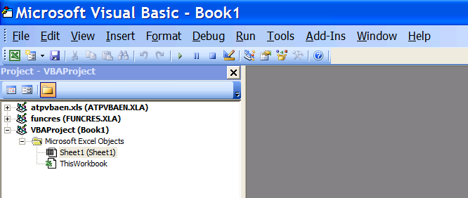
(Depending on all kinds of things, your screen may look different. Don’t worry about this.)

Hit Insert|Module
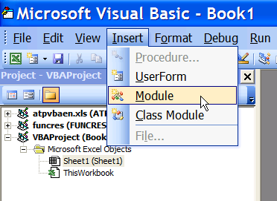
Now insert the following text into the Module window (just copy/paste from this document):
'Prints out formulas as text
'Thanks to Maja Sliwinski and Beni Czaczkes
Function getformula(r As Range) As String
Application.Volatile
If r.HasArray Then
getformula = "<-- " & " {" & r.FormulaArray & "}"
Else
getformula = "<-- " & " " & r.FormulaArray
End If
End function
Close VBA window (no need to save). The formula is now part of the spreadsheet and will be saved along with it.
Good luck,
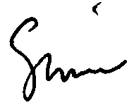
Simon Benninga
Benninga@wharton.upenn.edu

